SQL: Analyzing Queries

By Stephen Johnson

The following SQL commands will be used to analyze the results of queries for sales and returns by region to write a report for stakeholders.

(a)

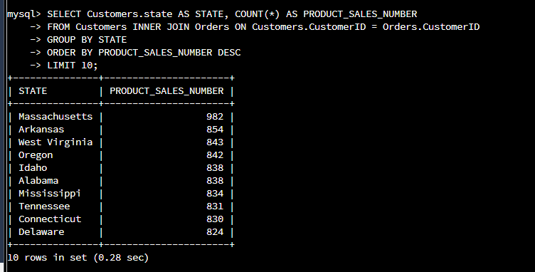

The top ten, with Massachusetts, Arkansas, and West Virginia having the most sales, are determined by using the command: **SELECT Customers.state AS STATE, COUNT(*) AS PRODUCT_SALES_NUMBER**

**FROM Customers INNER JOIN Orders ON Customers.CustomerID = Orders.CustomerID**

**GROUP BY STATE**

**ORDER BY PRODUCT_SALES_NUMBER DESC**

**LIMIT 10;**

(b)

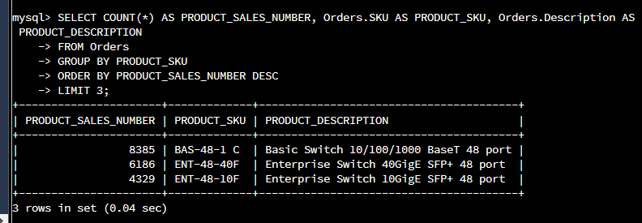

The top three products sold in the United States (the first being the Basic Switch with 48 port) are shown with the command: **SELECT COUNT(*) AS PRODUCT_SALES_NUMBER, Orders.SKU AS PRODUCT_SKU, Orders.Description AS PRODUCT_DESCRIPTION**

**FROM Orders**

**GROUP BY PRODUCT_SKU**

**ORDER BY PRODUCT_SALES_NUMBER DESC**

**LIMIT 3;**

(c)

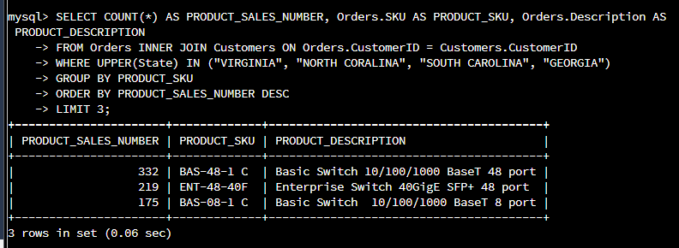

The top three products sold in the southeastern region of the US (the top of the three are shown as the Basic Switch with the 48 port), displayed with the command: **SELECT COUNT(*) AS PRODUCT_SALES_NUMBER, Orders.SKU AS PRODUCT_SKU, Orders.Description AS PRODUCT_DESCRIPTION**

**FROM Orders INNER JOIN Customers ON Orders.CustomerID = Customers.CustomerID**

**WHERE UPPER(State) IN ("VIRGINIA", "NORTH CORALINA", "SOUTH CAROLINA", "GEORGIA")**

**GROUP BY PRODUCT_SKU**

**ORDER BY PRODUCT_SALES_NUMBER DESC**

**LIMIT 3;**

(d)

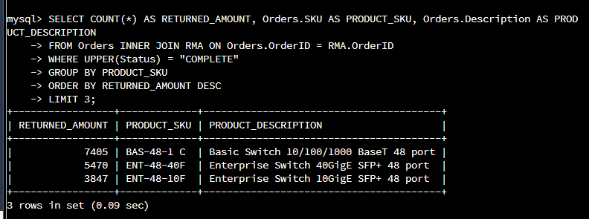

The top three products in the United States had the most returns, which, ironically, is the Basic Switch with the 48 port has the greatest amount. The command used was: **SELECT COUNT(*) AS RETURNED_AMOUNT, Orders.SKU AS PRODUCT_SKU, Orders.Description AS PRODUCT_DESCRIPTION**

**FROM Orders INNER JOIN RMA ON Orders.OrderID = RMA.OrderID**

**WHERE UPPER(Status) = "COMPLETE"**

**GROUP BY PRODUCT_SKU**

**ORDER BY RETURNED_AMOUNT DESC**

**LIMIT 3;**

(e)

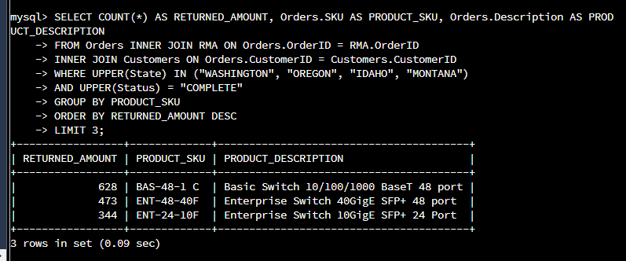

Finally, this screenshot determined the top three products in the northwestern region of the United States to have returns, which is the Basic Switch with 48 port, displayed by using the command: **SELECT COUNT(*) AS RETURNED_AMOUNT, Orders.SKU AS PRODUCT_SKU, Orders.Description AS PRODUCT_DESCRIPTION**

**FROM Orders INNER JOIN RMA ON Orders.OrderID = RMA.OrderID**

**INNER JOIN Customers ON Orders.CustomerID = Customers.CustomerID**

**WHERE UPPER(State) IN ("WASHINGTON", "OREGON", "IDAHO", "MONTANA")**

**AND UPPER(Status) = "COMPLETE"**

**GROUP BY PRODUCT_SKU**

**ORDER BY RETURNED_AMOUNT DESC**

**LIMIT 3;**

Sales information by region was explored within the database and ascertained while looking for the southeastern region of the United States. The product BAS-48-1 C or Basic Switch with 48 port was the results of the analysis with 332 being sold in the region. The ENT-48-40F or Enterprise Switch with 48 ports had the second highest sales in the southeastern region by selling 219 products. Additionally, the BAS-08-1 C or Basic Switch with 8 ports were able to attract 175 sales.

With the return of information by region being examined, we were able to conclude that 628 of the Basic Switch with 48 ports products had the highest return. This high return occurred in the northwestern region of the United States. The ENT-48-40F or Enterprise Switch with 48 ports had the second highest return amount with 473 products. Finally, ENT-24-10F or Enterprise Switch with 24 ports had the third most returns by region with 344 products.